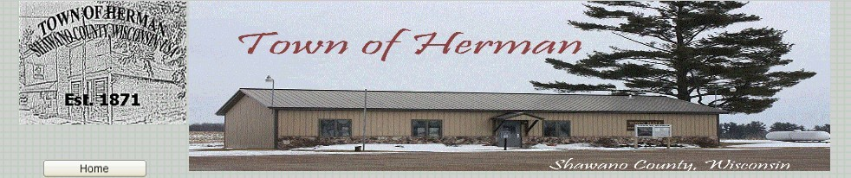

Dear WEDC:

It is my understanding AHLERS SEAMLESS RAIN GUTTERS LLC located at N5674 Leopoplis Rd, Leopolis, WI was in business February 2020.

We support the continued operation of this business and recommend AHLERS SEAMLESS RAIN GUTTERS LLC be considered for the We’re All In grant opportunity.

With best regards,

Robert Kristof
Chairman
Town of Herman, Shawano County, Wisconsin

