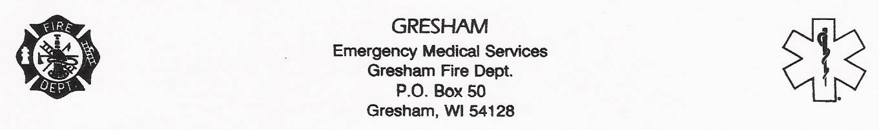

GRESHAM AREA FIRE BOARD MEETING
THRUSDAY, SEPTEMBER 20, 2018 6:00 P.M.
GRESHAM FIRE STATION
LOCATED, 1300 MAIN ST
GRESHAM, WI

AGENDA:

1. Call Meeting to order
2. Reading and approval of previous meeting minutes.
3. Discussion and possible action for Fire Board Chairperson
4. Fire Chief Report
5. General Fire Board Topics
6. Adjournment

Thomas Madsen, Secretary

POSTED DATE: 09/13/2018, Time 11:30 a.m.
GRESHAM STATE BANK
GRESHAM POST OFFICE
VILLAGE HALL

