INVOICE:
Robert Kristof – WebMaster – Town of Herman-Shawano.com
Webmaster Wages $500 for setup and 1st year of updates.
$200/yr each additional year.

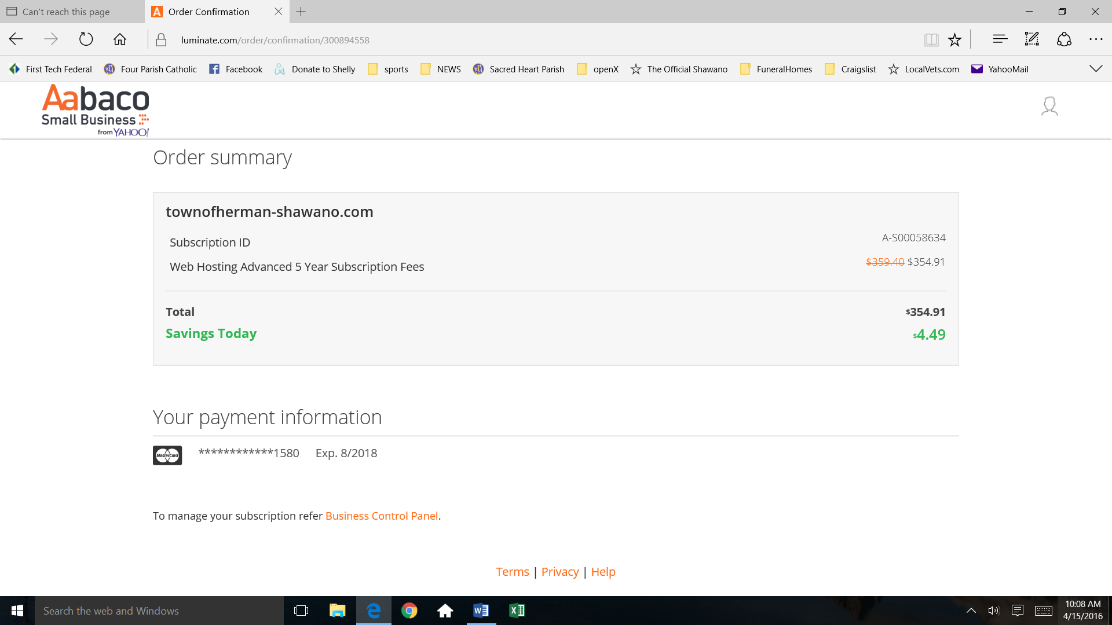

Total : $500.00 Wages
$354.91 5 years of Web Server and Domain Name Cost.
---------------------------
$ 854.91

