Harter’s Fox Valley Disposal
RECYCLING GUIDE
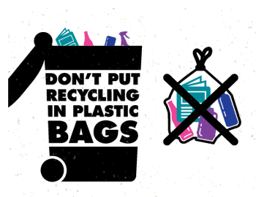
ALL RECYCLABLES SHOULD BE PLACED IN A CONTAINER
OF 35 GALLONS or LESS.
PLEASE LABEL CONTAINER AS “RECYCLING”

PLASTIC:

ACCEPT DO NOT ACCEPT
All Plastic Bottles & Containers: NO Plastic Bags, Wrap or Film
Soda, Water, & Other Drink Bottles No Motor Oil Bottles
Food & Household Bottles, Jars and Jugs No Styrofoam
Dairy Containers & Lids
Produce, Bakery & Deli Containers

GUIDELINES:
Empty and rinse all bottles and containers Remove and discard all screw caps

PAPER:

ACCEPT DO NOT ACCEPT
Newspapers & Insert No Paper Contaminated by
Cardboard & Paperboard Food or Grease
Junk Mail & Office Paper No Tissue
Milk, Juice & Soup Cartons No Gift Wrap
Phonebooks, Books, Magazines & Catalogs

GUIDELINES:
Flatten and cut cardboard to no larger than 2’ x 2’
Place shredded paper in paper bag, secure and label

METAL AND GLASS:

ACCEPT DO NOT ACCEPT
Aluminum Bottles & Cans No Aluminum Pans or Foil
Steel, Tin & Bi-metal Cans No Empty Paint Cans
Empty Aerosol Cans
Food & Beverage Bottles and Jars

GUIDELINES:
Empty and rinse all bottles and containers
Remove and discard all screw caps

